February 26, 2024

SUBJECT:HB468 RANGELAND – Adds to existing law to establish the Rangeland Improvement Act.

Dear Representative Raymond,

Idaho Business for the Outdoors supports the passage of House Bill 468.The bill aims to establish a fund and a program for landowners to enroll their lands and grazing allotments in Rangeland Improvement Districts. IBO believes this bill provides a useful tool for ranchers and land managers to improve the health of their lands.

Idaho Business for the Outdoors is a business member-based organization. Our mission is to provide a collective, non-partisan business voice that advocates for healthy lands, open space, and swimmable, fishable, and drinkable waterways. We value the role agriculture plays in the preservation of Idaho's outdoors and waters. This bill aims to ensure ranchland stays economically viable and maintains the opportunity for healthy lands.

Our membership is made up of industries and businesses of all sizes including some of the largest employers in Idaho. Open space, healthy lands, and waters promote investments, innovations, jobs, enhance revenues, and provide wellness benefits. We believe this is an important investment in Idaho’s rangelands and we support the passage of HB 468.

Best Regards,
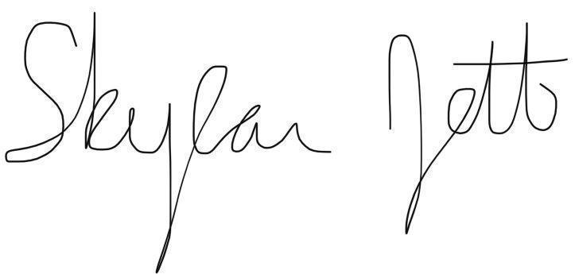
Skylar Jett, Executive Director, Idaho Business for the Outdoors

